# Institute of Technology Tallaght Dublin

**Department of Computing**



**CA Title:**  Create A 2D Game In Unity Engine

**Module:** Interactive Media Development

**Lecturer:** Enda Lee

**Student Name:** David Kiernan

**Student Number:** X00093830

**Due Date:**  10th March 2017

**PART 1.**

**GAME**

The game that was chosen to recreate was Space Invaders arcade game that was released in 1978.

It is a fixed shooter

**GAMEPLAY**

It is a simple gameplay in which the player controls a ship that can only move from side to side along the bottom of the screen, firing at the incoming enemies called aliens.

The player is protected to a degree by serval bunkers that don’t move that are gradually destroyed by receiving hits by either type of enemy and also the player

These aliens are normally set to 5 rows of eleven aliens that will move left to right hit a point (Boundary) then drop down a row until they reach the player at which point the invasion is a success and the game ends.

The aim is for the player to defeat the enemies by shooting them which will earn points. Normally the first two rows are worth a score of 10 the third and fourth row are worth 20 with the top row worth 30.

There is also a mystery ship whose score tends to be a value of 50,100,150 or 300 points.

Normally an extra life is awarded once a player at either 1000 or 1500 points but in the recreated game it is an extra life for every level completed until a max number of lives is reached then no extra life will be added.

On computers or laptops the controls tend to be

* D or Right Arrow key to move right
* A of Left Arrow Key to move left
* Space Bar to Fire
* P key to Pause.

Creating the game in Unity

Scripts for the game. (KillerKerney)

* Missile Controller
* Saucer Controller (mystery Ship)
* Score Controller

Along with the Sounds & Materials used in the game can be found

The Images used where taken from Google Image search of Space Invaders (vignette1, no date)

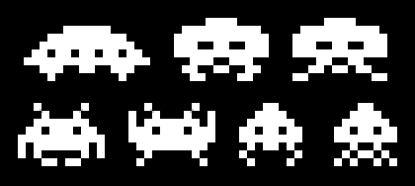

Player and Barrier (anseo, no date)

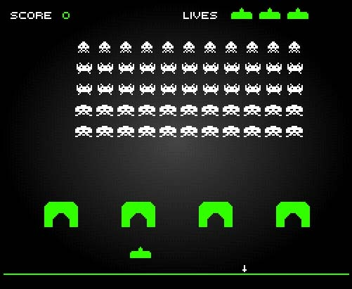

**PART 2**

Space Invaders still offers a great experience despite its age as the game is almost 40 years old, this is most likely due to how easy it is to play all the player needs to now is how to fire and also the way the music is set that it gets more urgent as the enemies get closer, and anyone can play it. There are a few ways in which the game can be improved.

**Graphics**

This is what the graphics for the game looks like for the enemies which are white, the player at the bottom and the bases.

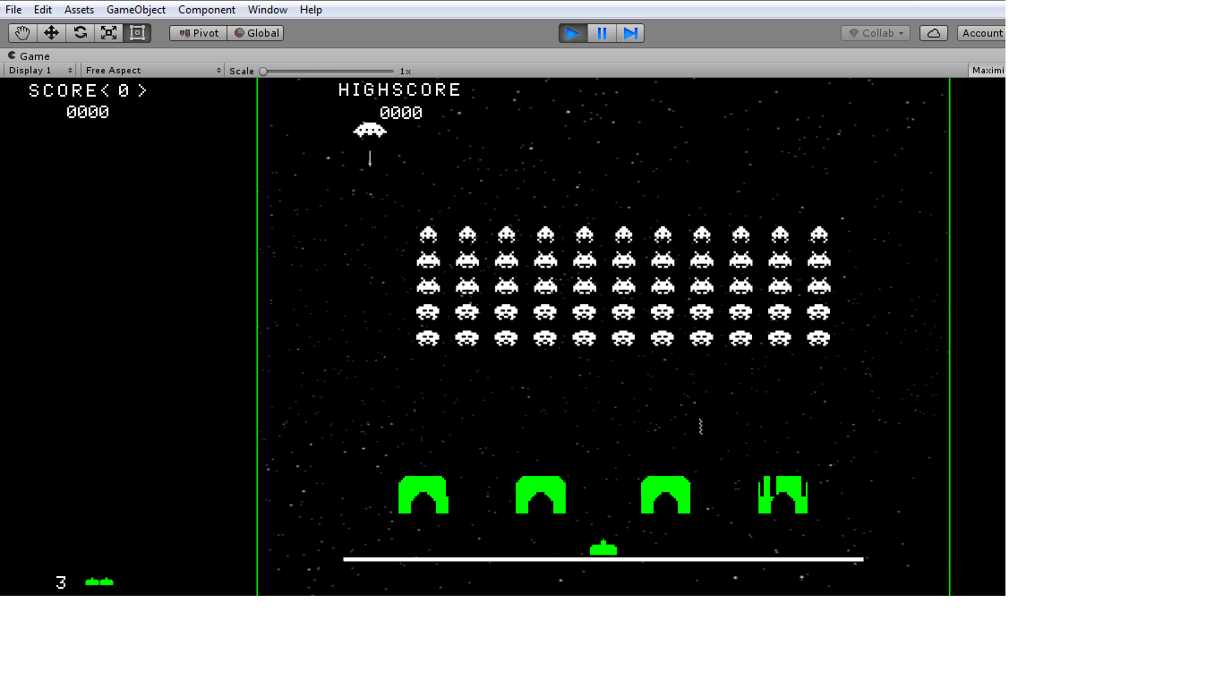

The player can be upgraded to look like

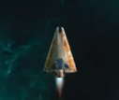

The enemies could also be upgraded to look something along the lines of

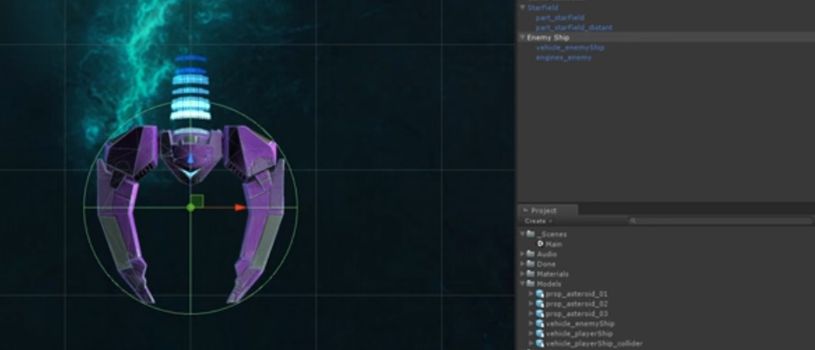

**User Interaction**

While the background does not need to be upgrade maybe given the user the option to select the background to use.

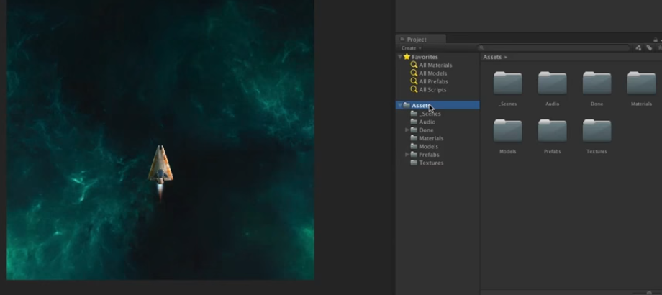

Or even the ability to select the colour of various enemies each type has its own colour.

There are different colours in the materials folder in the asset folder but this will only change the colour before the project is built.

No improvements can be on the controls.

**Gameplay**

Adding different kind of enemies and also allowing the player to move up to attack the enemies and have the enemies drop down without all the enemies appearing on screen at once.

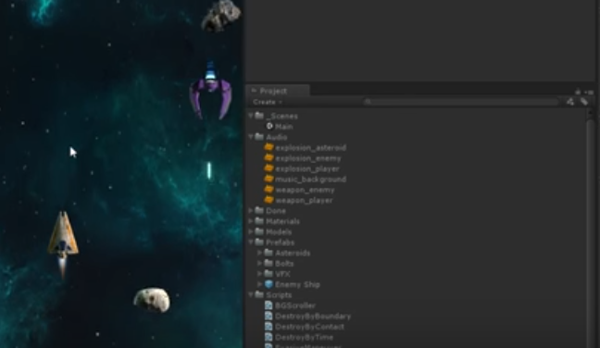

Maybe the introduction of a boss level that appears every five levels that consists of one enemy that moves slightly faster than the rest and also fires multiple missiles at once and fires them faster than the other enemies.

**References:**

**Part one** of the game was created with

Gamesplusjames endless runner tutorial

Available from <https://www.youtube.com/watch?v=GrQalFLtQT4&list=PLiyfvmtjWC_XmdYfXm2i1AQ3lKrEPgc9->

[Accessed 28th February]

KillerKerney script, sounds and materials

Available from <https://github.com/KillerKerney/Space-Invaders/tree/master/Assets/Game%20Assets>

[Accessed 12th March]

Unity Documentation

Available from <https://docs.unity3d.com/Manual/index.html>

[Accessed 12th March]

vignette1 (Enemy sprites)

Available from:

<http://vignette1.wikia.nocookie.net/villains/images/9/9b/Spaceinvaders.png/revision/latest?cb=20130815215326>

[Accessed on 28 February]

Player and Barrier (anseo, no date)

Available from:

<http://www.anseo.net/wp-content/uploads/2013/03/space-invaders.jpg>

[Accessed on 28 February]

**Part Two**

All the upgraded images

Unity Space Shooter Tutorial

Available from <https://unity3d.com/learn/tutorials/projects/space-shooter-tutorial>

[Accessed 8th March]